Web App Lab #03:

Client Side - Javascript

Lab Overview:

In this lab you will:
- Revision Client Side Processing
- Create Login & SignUp applications with validation
- Create a game containing spinning images
- Use HTML, CSS and JavaScript

Lab Order:
Task 1: Using HTML, Javascript for Client side processing
Task 2: Exposure to Client side / Server side processing
Task 3: Design and write a Registration Form with validation to be used with future application.
Task 4: For Fun! Whirling Image Game

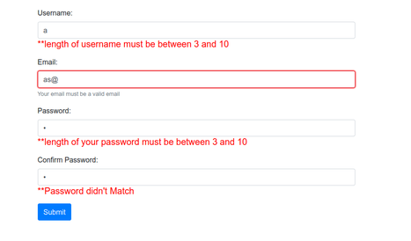

Lab Tasks:
Task 1:
Using HTML

Create a login screen similiar to below (Mailchimp login screen)
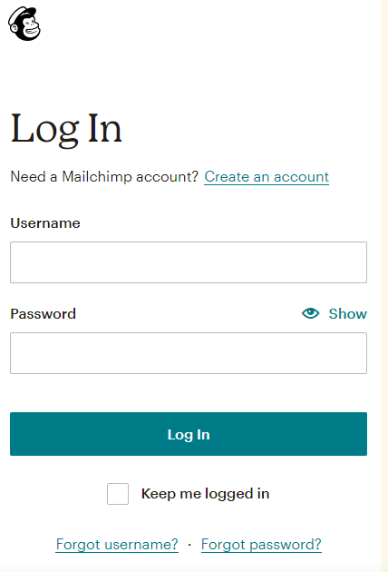
<html>
<head>
<title>Login Page</title>
</head>
<body>
<form>

<label>UserName :</label>
<input type = "text" name = "username" />
<br /><br />
<label>Password :</label>
<input type = "password" name = "password" />
<br/><br />
<input type = "submit" value = " Submit "/><br />

</form>

</body>
</html>
To contain:
Username entry, Password entry, Submit button , Registration Link

Optional extras:
Show Password, Remember Me, Forgotten Username/Password

Suggest Client side Processing which could occur with this screen

Add Javascript to execute your suggestions (see sample code below)

Task 2:
2.1 Adding the current date and time to a web page using client-side web page processing.
Create a HTML file called date.html save it in c:\wamp64\www folder and add the following javascript code:

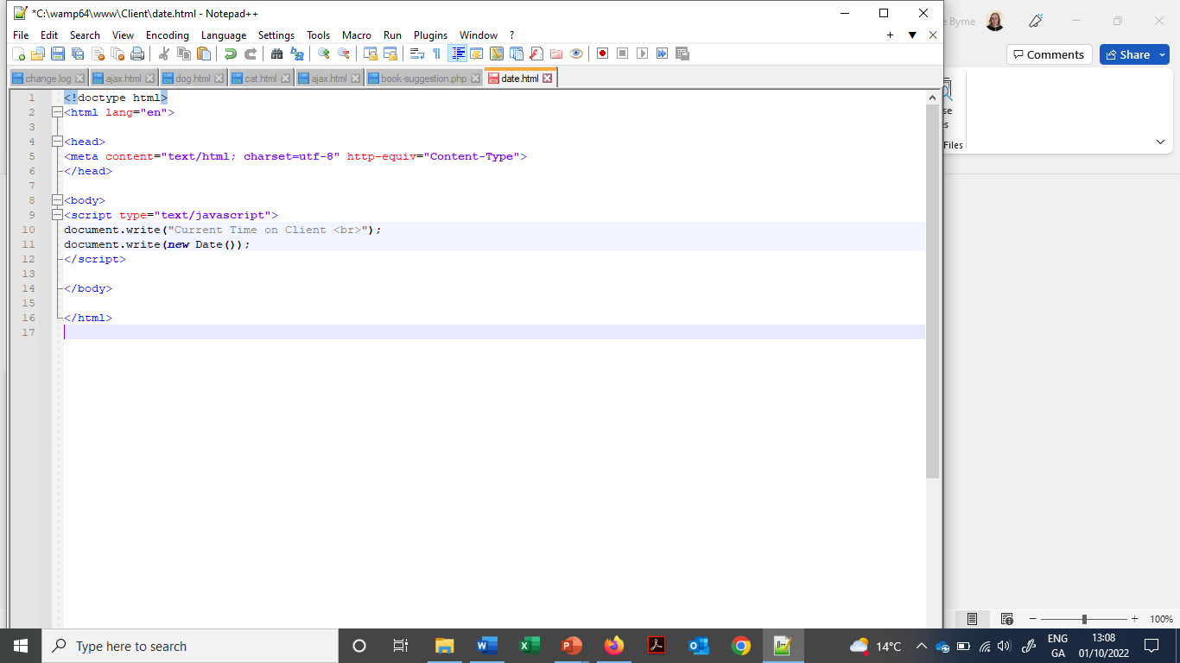
Run this file

2.2 Adding the current date and time to a web page using server-side web page processing
Rename the HTML file date.html to date.php and add the following php code:
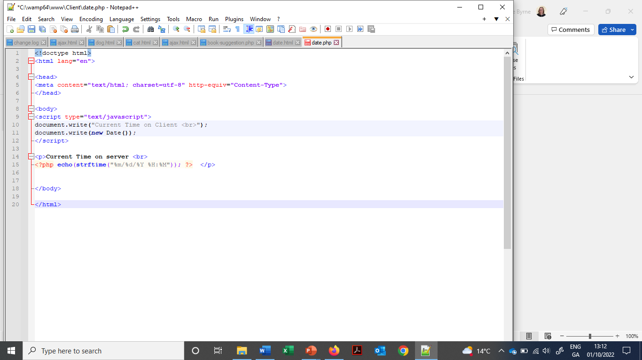
The full file should look like this:

Run this file

  - Explain why the date and time for (a) may be different than (b)

Task 3:
Design and write a Registration Form with validation to be used with a future application (No back end yet!) – similiar to form on page 1 of this lab sheet
Validation & Java script examples:
<form>
<label for="firstname"> First Name: </label>
<input type="text" name="firstname" id="firstname" required maxlength="45">
<label for="lastname"> Last Name: </label>
<input type="text" name="lastname" id="lastname" required maxlength="45">
<button>Submit</button>
</form>

Reference: https://www.w3resource.com/javascript/form/javascript-sample-registration-form-validation.php
<html>
<script>
function formValidation()
{
var uid = document.registration.userid;
return userid_validation(uid,5,12)
}

function userid_validation(uid,mx,my)
{
var uid_len = uid.value.length;
if (uid_len == 0 || uid_len >= my || uid_len < mx)
{
alert("User Id should not be empty / length be between "+mx+" to "+my);
uid.focus();
return false;
}
return true;
}
</script>
<body>
<form name='registration' onSubmit="return formValidation();">
<label for="userid">User id:</label>
<input type="text" name="userid" size="12" />
<label for="passid">Password:</label>
<input type="password" name="passid" size="12" />
<input type="submit" name="submit" value="Submit" />
</form>
</body>
</html>

Good reference: https://www.tutorialspoint.com/javascript/javascript_form_validations.htm

Task 4: For Fun! Whirling Image Game

Using Javascript and the DOM, make a little image game that has the images rotate for an onmouseover event and stop on an onclick event.
4.1 Unzip the given folder SmartPhones to www folder into new folder called SmartPhones.

This folder should contain files below. Open these files (using Notepad++) and write a one-line description of what they contain. The folder information has already been filled.

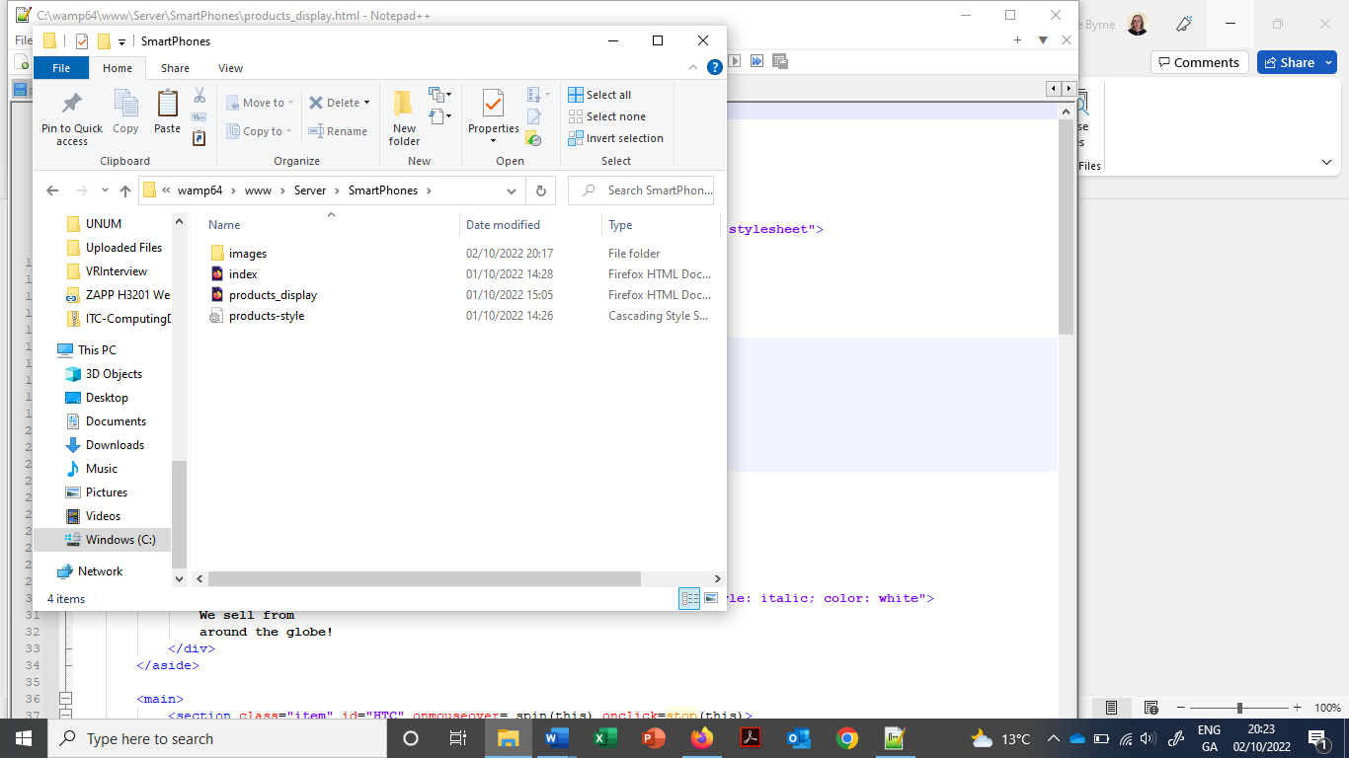
- folder of images

4.2 Run this application by typing: localhost/SmartPhones/index.html
The icon spins when the mouse moves over it. Refresh the page to stop the spin!
Note the onmouseover event for the first <section>. This event is called spin() – The this reference is used to access the DOM object for the current element.
It sets the className property to “item rotate” (from CSS file)
function spin(element) {
element.className="item rotate";
}

4.3 Update the other <section> tags of the other three images.

4.4 Now set the onclick event attribute for <section> elements to set the className to just 'item'.
Refresh the page after saving the file and move the mouse over an image to get it spinning. When you click on the image it should stop.
The game is to get everything spinning and see how quickly you can get all of them to stop by clicking on the images.

